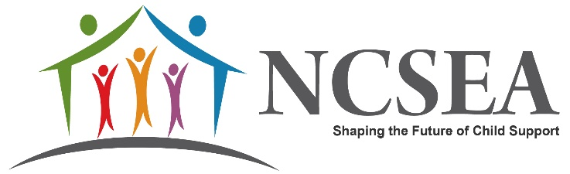
NCSEA JOB BOARD POSTING
NCSEA offers the child support professionals community the opportunity to post any open positions on its website for 60 days. If you would like to include a job to be featured on our Job Board, complete this form and email to Amalia Paul NCSEA Membership Coordinator. Please maintain the Word format; do not send in PDF.

Job Title:

Organization/Company:

Location:

Job Description:

Responsibilities:

Qualifications (education, experience, etc.) both required and preferred qualifications and skills:

Application Information (include PDF or link to website if applicable):

